OPET

Open PV Electrical Tool

PCB manufacturing Notes

OPET REV 1.4

Contact Byron McDanold (NREL) in case of questions:

May 2, 2023

Version 0.93 first draft

byron.mcdanold@nrel.gov 303-275-4706

Table of Contents

1 Introduction 1

2 PCB manufacturing requirements 1

3 PCB Assembly requirements and instructions 2

3.1 Component orientation 2

3.1.1 Orientation definitions 2

3.2 Through-hole components with heatsinks 5

3.2.1 All OPET versions 6

3.2.2 Low-Current OPET version 6

3.2.3 High-Current OPET version 6

# Introduction

* This document contains further information with regards to the PCB design and PCB manufacturing of OPET boards
* OPENT comes in 2 versions: low-current (340 mA) and high-current (15 A) version
  + Both use the same PCB with some changes in components
* Includes:
  + PCB manufacturing requirements
  + PCB assembly requirements and instructions

## Overview Low-Current OPET version

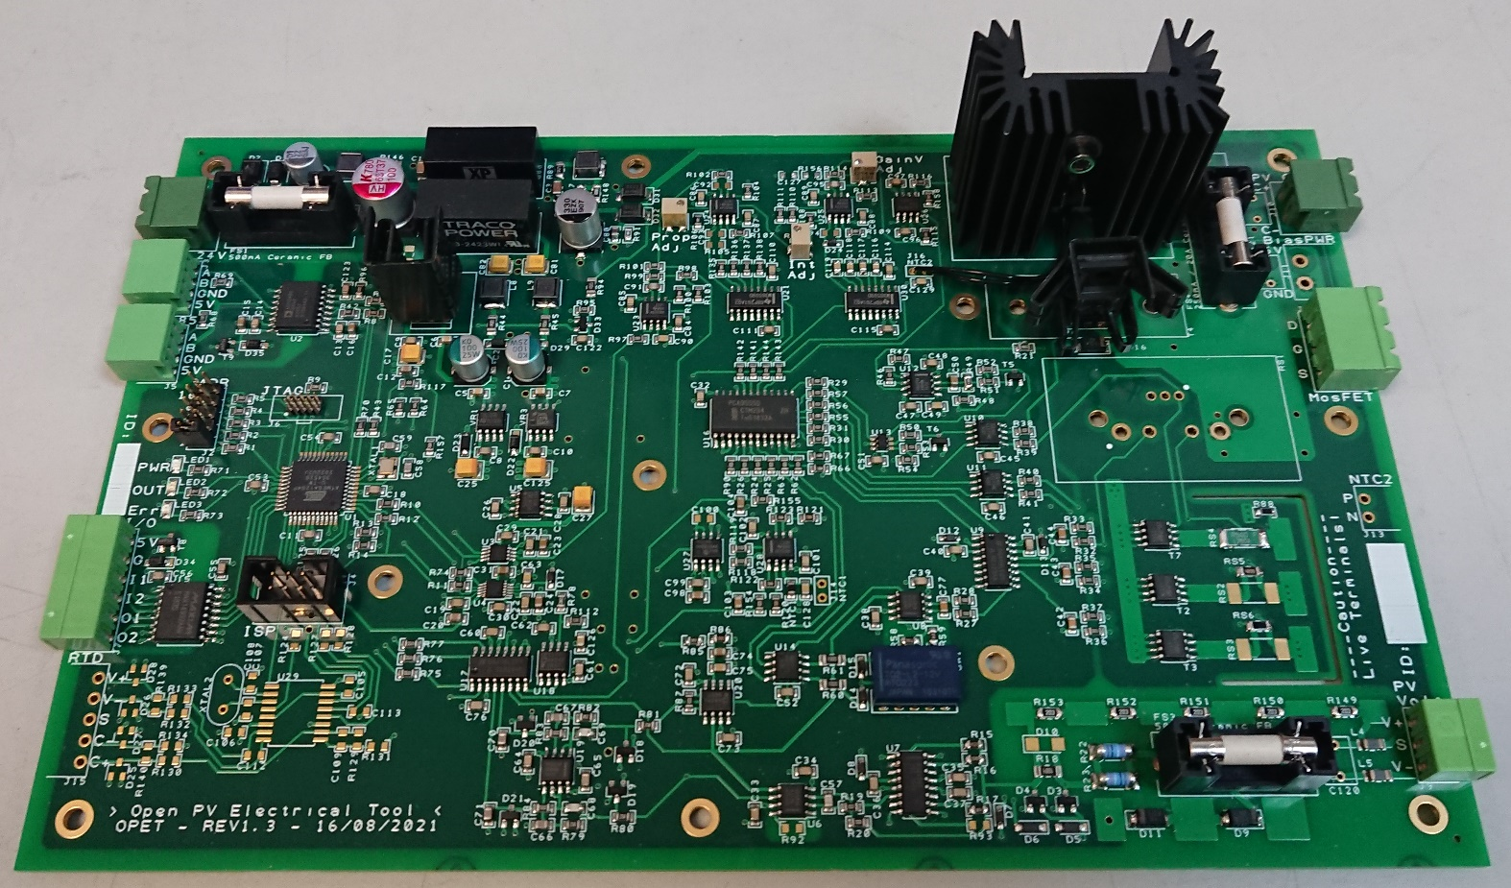

Figure 1: Photo of previous test version of low-current OPET, the current version is slightly different

## Overview High-Current OPET version

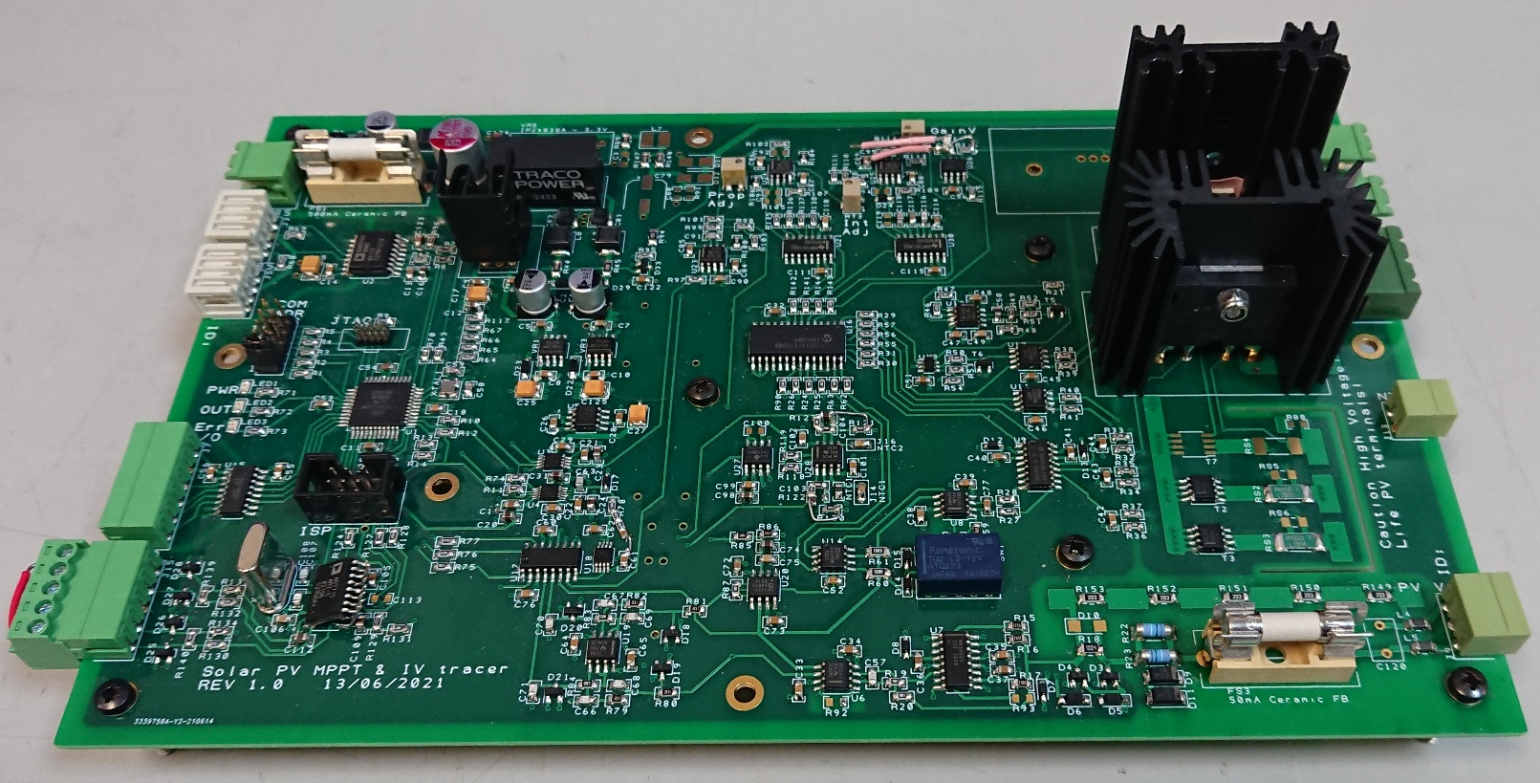

Figure 2: Photo of previous test version of high-current OPET, the current version is slightly different

# PCB manufacturing requirements

* The OPET board is a 4-layer PCB
* Following copper layer thickness is recommended:
  + top and bottom layer 1 and 4
    - 1oz copper thickness (~35 µm)
  + inner layers 2 and 3:
    - 2oz copper thickness (~70 µm)
* following 4-layer PCB structure should be used (see Figure 1):
  + the full PCB should be 1.6mm thick
  + the layers 1 to 2 and 3 to 4 should be separated with a thin prepreg sheet (~0.2 mm)
  + the layer stack should have a centre core sublayer (~1.0 mm) between the inner layers 2 & 3
    - high voltage parts of the OPET PCB are separated such that the inner core sublayer is the main insulator where tracks with high voltage potential cross



Figure 3: recommended PCB layer stack configuration, use 2oz of copper thickness for inner layers and 1oz of copper thickness for outer layers

* PCB material:
  + FR4 TG155 or similar
    - * good high temperature resistance is needed
* PCB finish:
  + should be ENIG (Electroless Nickel Immersion Gold)

# PCB Assembly requirements and instructions

## Component orientation

* Before PCB assembly correct orientation of components on the PCB should be checked
  + orientation has to be correct for assembly with a pick and place machine to be successful
  + a component placement preview image/diagram from the manufacturer should help make sure orientation is correct before assembly starts
* following sections detail the zero-orientation various component package types

### Orientation definitions

* Zero rotation as shown in the figures
* **2 pin diodes:**
  + pin 1, left: C – Cathode
  + pin 2, right: A – Anode
  + zero rotation has pin 1 on left side



Figure 4: 2-pin diode, zero rotation, pin 1 shown on the left side

* **2 pin polarized capacitor:**
  + pin 1, left: -, negative
  + pin 2, right: +, positive
  + zero rotation has pin 1 on left side



Figure 5: 2-pin polarized capacitor, zero rotation, pin 1 shown on the left side

* **2 pin electrolytic capacitor:**
  + pin 1, left: -, negative
  + pin 2, right: +, positive, also marked with the (+) sign
  + zero rotation has pin 1 on left side



Figure 6: 2-pin polarized electrolytic capacitor, zero rotation, pin 1 shown on the left side

* **44-lead TQFP:**
  + Pin 1 marked with extended line on silkscreen
  + Zero rotation has pin 1 in lower left corner



Figure 7: 44-lead TQFP, zero rotation, extended line on pin 1 shown in the lower left corner

* **SOIC, µMax, TSSOP and similar ICs:**
  + Pin 1 marked with extended line on silkscreen
  + Zero rotation has pin 1 in lower left corner



Figure 8: SOIC, µMax, TSSOP and similar ICs, zero rotation, extended line on pin 1 shown in the lower left corner

* **SOT (the exception):**
  + Pin 1 marked with extended line on silkscreen
  + Zero rotation has **pin 1 in lower right corner**



Figure 9: SOP, zero rotation, extended line on pin 1 shown in the lower right corner

* **Relays, DIL, DIP:**
  + Pin 1 marked with notch in line on silkscreen
  + Zero rotation has **pin 1 in lower left corner**



Figure 10: Relays, DIL, DIP, zero rotation, notch marking near pin 1 shown in the lower right corner

* **Through-hole SIL Connectors:**
  + Connector cable input direction / plug entry on open side of silkscreen shape
  + Zero rotation has pin 1 on the left side and open side of silkscreen on the bottom



Figure 11: Through-hole SIL Connectors, zero rotation, cable input direction / plug entry from the open shape side, pin 1 on left side

* **SIL components, SIL headers:**
  + Pin 1 marked with dot
  + Zero rotation has pin 1 and dot marking on the left side



Figure 12: SIL components and headers, zero rotation, pin 1 on left side marked with dot

* **Through-hole header connectors:**
  + Pin 1 marked with dot
  + Zero rotation has pin 1 and dot marking on the lower left side, notch marking pointing towards the bottom



Figure 13: Through-hole header connectors, zero rotation, pin 1 on lower left corner marked with dot and notch marking pointing towards the bottom

## Through-hole components with heatsinks

* Components with heatsinks have multiple parts on the same component identifier with an additional letter at the end (for example VR2_A for the voltage regulator and VR2_B for the heat sink)
* This section details how to mount components with heatsinks onto the OPET board and where insulating pad or thermal paste is needed
* some instructions differ between high and low current OPET versions
* When soldering through hole components with large heatsinks to the PCB:
  + make sure there is a ~1.5 mm gap between the heatsink/component body and PCB
  + This is to make sure that the heatsink is not contacting and shorting tracks on the PCB and to maintain voltage rating
  + solder the heatsink locating pins to the PCB to stop the component from moving or vibrating
* When instructed to use a TO-220 electrical insulating pad:
  + The part then needs to be mounted with an electrically isolating but thermally bonding pad and nylon bush
  + a TO-220 insulating kit such as Newark 50P9593 (MK3306) should work
  + Use a thin pad with high thermal conductivity
  + Max voltage to insulate is 150 V under normal operating conditions
  + The nylon bush is needed to make sure the screw does not make a new contact
  + Make sure the nylon bush has a deep enough rim to go through the component mounting hole and partly into the heatsink screw hole
    - A nylon bush rim that is too shallow will cause a short between component and heatsink
  + Use metal washers at screw head and nut end to spread the contact force on the nylon bush

### All OPET versions

* VR2:
  + the 5V regulator should be mounted onto the heatsink without any electrically insulating pads or thermal paste
  + bend the heatsink fins as needed to secure the TO-220 voltage regulator
  + If a hole for screw mounting is available, secure part using M3 screw, nut and washers

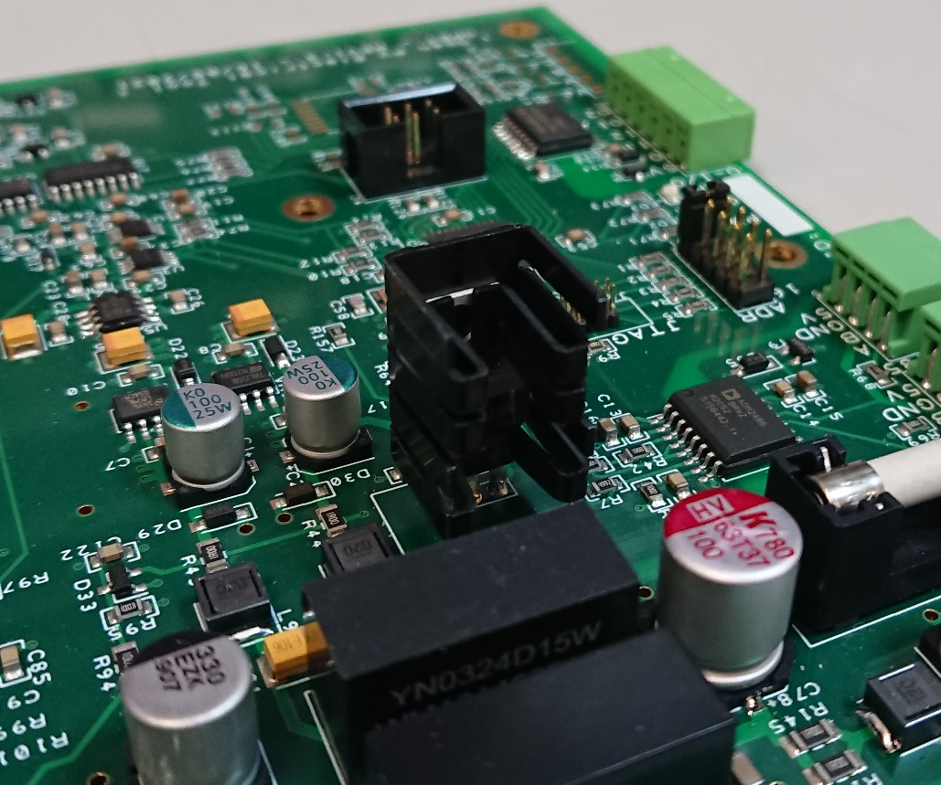

Figure 14: Image of VR2 on OPET PCB, the actual heatsink may vary slight and will be either clamp-fit or screw-fit

### Low-Current OPET version

|  |  |
| --- | --- |
|  |  |

Figure 14: Low-current OPET: Left: front side of T1 with driver MosFET; Right: rear side of T1 with NTC sensor bolted to the back of heatsink and T4 MosFET fixed to small heatsink using either clamp-fit or screw-fit as required

* T1:
  + The driver MosFET needs to be mounted with insulating pad and bush
  + In addition, the NTC sensor needs to be mounted to the heatsink
  + The NTC sensor should be mounted at the back of the heatsink, on the opposite side of the MosFET
  + The NTC leads need to be wire soldered onto J16
  + Solder the heatsink with MosFET with a 1.5 mm gap to the PCB as detailed previously
  + the heatsink location pins should be soldered to the PCB to provide best stability
* T4:
  + The overcurrent bypass MosFET does not require any additional thermal pads when mounting to the small heatsink
  + Due to the thicker MosFET body it may be required to bend some of the heatsink fins to ~45° before it can be inserted
  + If a hole for screw mounting is available, secure part using M3 screw, nut and washers

### High-Current OPET version

|  |  |
| --- | --- |
|  |  |

Figure 14: High-current OPET: Left: front side of T4 and RS1; Right: rear side of T4 and RS1; both heatsinks have a component screw mounted on both sides of the heatsink with electrically insulating pats and bushes or thermal paste, as detailed below

* T4:
  + The overcurrent bypass MosFET and bypass diode must be mounted together onto the heatsink
  + the MosFET must be mounted with a thermal pad as detailed at start of the main section
  + if the diode has an insulated body with a plastic base, it needs thermal paste to provide a good thermal contact to the heatsink
  + if the diode has a metal base, it needs an insulating pad and bush
  + solder the heatsink with components onto the PCB with a ~1.5 mm gap between the heatsink body and PCB
  + the heatsink location pins should be soldered to the PCB to provide best stability
* RS1:
  + The 15A shunt resistor needs to be mounted onto the heatsink together with the switching MosFET
  + To mount the components onto the heatsink a new screw hole must be drilled first
    - This needs to be 4 mm below the existing screw hole or 15mm from the bottom of the heatsink body excluding the locating pins
    - Deburr the newly drilled hole and make sure the contact area is flat and clean
    - The existing screw hole is too far from the edge for the short shunt resistor pins to reach through the PCB with a 1.5 mm gab between the PCB and heatsink
  + The MosFET must be mounted with an insulting pad as detailed at start of the main section
  + The Shunt resistor, if using standard BOM part, has a metal base that is insulated from all contact pins and hence should be mounted with high quality thermal paste
    - High quality meaning high thermal conductivity
  + the heatsink location pins should be soldered to the PCB to improve stability